**Project Title: Global Economical Data Analysis**

**Project Abstraction**:

Analysing and deriving actionable insights from global economic data is crucial for businesses, policymakers, and researchers to make informed decisions and navigate the complex global landscape. The problem statement aims to address the need for leveraging IBM Cognos to achieve comprehensive analysis and actionable insights from global economic data.

**Charts and Uses:**

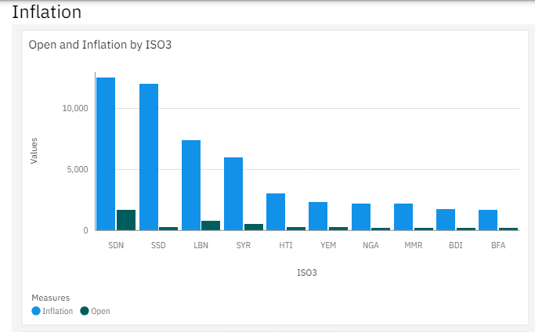

The above chart shows the rate of open and inflation in retail products of different countries as of 2023.

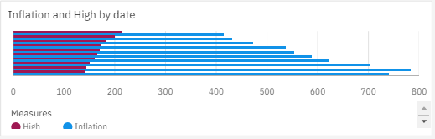

This chart shows the open and inflation of the same countries but in accordance with the date and year as of 2023.

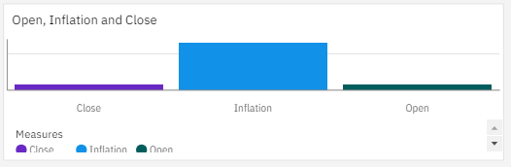

This above chart again, shows the open, inflation and close values of inflation in retail goods and products globally as of 2023.

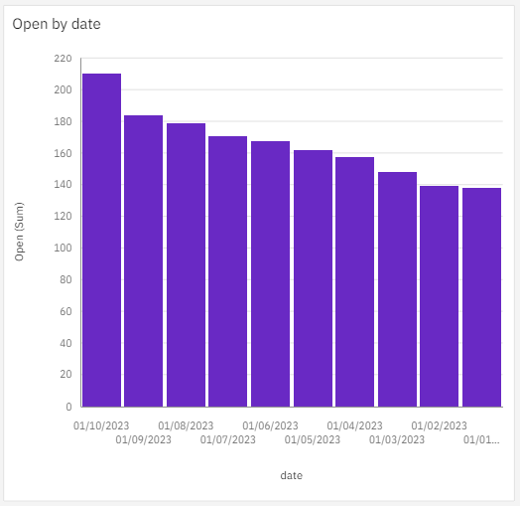

Next, the Open values of different dates of inflation as of 2023 are given above. It gives a clear picture of almost every month and its inflation rates in the global market.

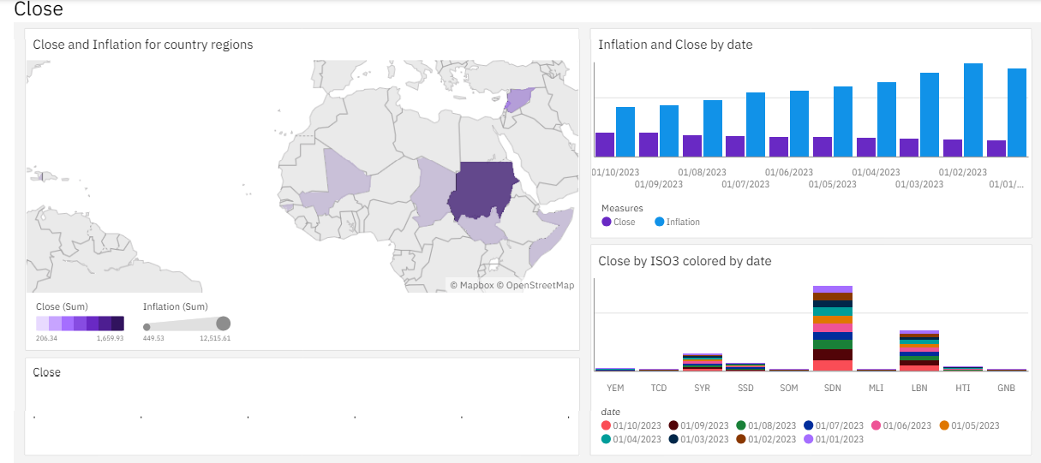

The close market values of the same retail goods in different months of 2023 are charted as above.

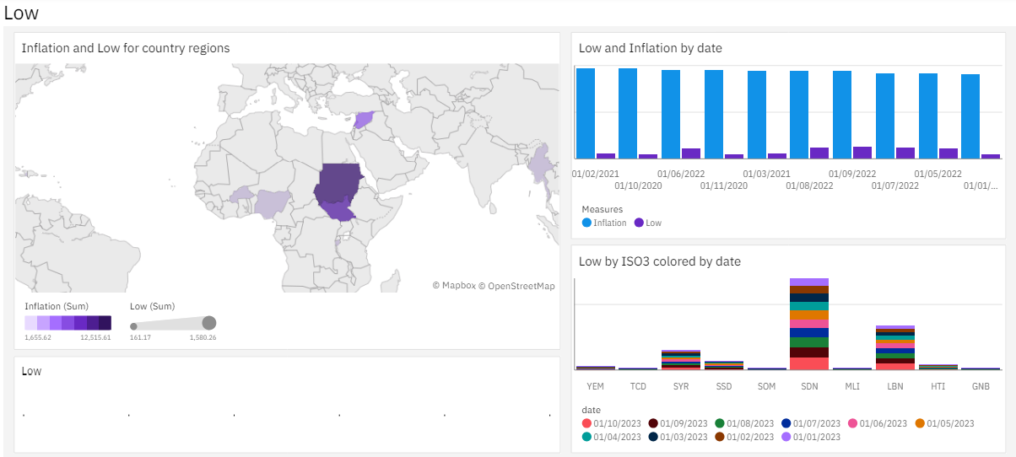

The low and lowest market values of the same retail goods in different months of 2023 are charted as above.

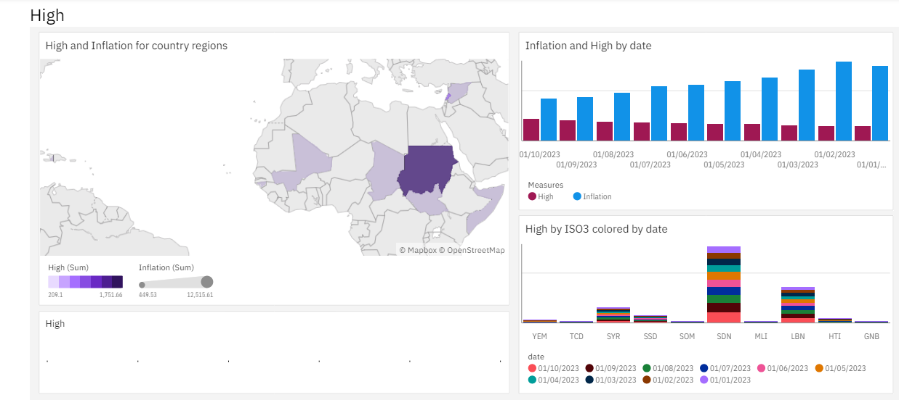

The high and highest market values of the same retail goods in different months of 2023 are charted as above.

**Conclusion:**

The Dashboard shows the open rates, close rates, inflation rates, highest inflation, lowest inflation and average inflation rate of some retail products in the global market as of 2023. It also creates easy accessibility on the whole data set as we can visualize the whole details of the given data set and conclude a decision.

**Team Members:**

1. Shahira Shabnam S – 221191101133
2. Saranya N – 221191101125

**Dashboard Link:**

https://us1.ca.analytics.ibm.com/bi/?perspective=dashboard&pathRef=.my_folders%2FNew%2Bdashboard&action=view&mode=dashboard&subView=model0000018f99d121ff_00000000